

**IR35 Fact Sheet Maintained Schools**

**Public Sector IR35 Legislation “Off-Payroll Workers” - How to direct Source an off payroll worker**

*Consideration of IR35 status should be undertaken prior to any engagement, not at the payment stage*

You will need to have read the Factsheet **Public Sector IR35 “Off-payroll Workers” – An introduction to your Responsibilities from previous communication on school Website > Bulletin > Issue 510.**

**The important obligations of Budget Holders/ Hiring Managers to process the evidence required by HMRC in placed to all organisations on 6th April 2017 and the following consecutive tax years.**

1. **Direct Sourced Worker Process.**

As a Budget Holder/Hiring Manager it is important you understand the requirements before engaging a business/worker to commence.

* Determine the IR35 Status

Inside or Outside – Complete check employment status of tax (CEST)

* **On Boarding**

The Budget Holder/Hiring Manager must check and retain copy of:

* References
* Qualifications
* Company UTR (Unique Tax Reference)
* Company ERN (Employee Registration number)
* Sole Trader UPN (Unique Personal Number)
* Any other checks relevant to the job role and services provided

Maintained Schools will need to complete the standard recruitment process for:

* DBS Check
* Qualifications
* Right to work in the UK

1. **Payments**
   1. All directly sourced workers **inside IR35** must be paid via an Umbrella agency or a payroll bureau so that that they can be tracked and compliance checked. There will be an administration fee which will be deducted from the directly sourced worker’s fee. This fee is a cost of the worker’s business and should not be passed back to the Maintained School. This fee will cover the cost of administering the IR35 process, on boarding advice and making the calculations to enable payment.



The off payroll worker will need to provide the details of a payroll bureau or Umbrella company whom they want payment to be made to. The Umbrella company will then deduct the applicable Tax and NI and remit the Net amount to the off payroll worker.

* 1. All directly sourced workers **Outside IR35** will be paid through vendor process so need to be set up as a new vendor with Harrow Procurement team.

1. **Agency Direct Sourced Worker Process**

When you source via an Agency all of this administration process will be managed for you, however you will still need to make the **IR35 status determination**.

1. **How do I decide the IR35 status?**

If using the graphic below a role ‘looks like employment’ then a hiring manager can make an automatic assessment of inside IR35.

A list of inside IR35 roles are starting to be made including:

* All classroom teaching roles
* Interim Head Teacher
* Clerks to the Governors
* 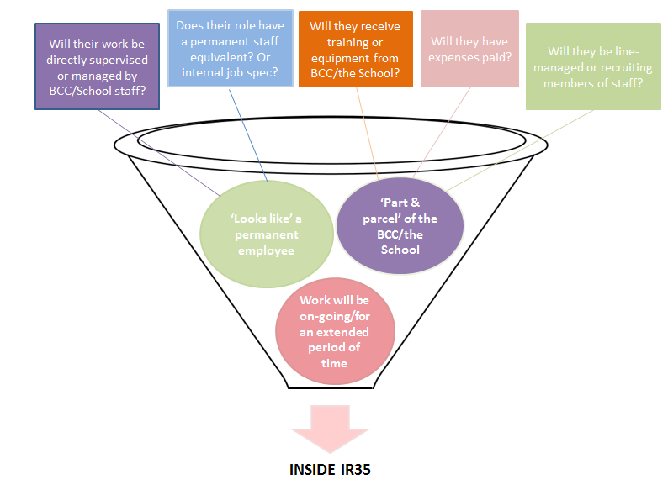Any other vendors determined inside IR35

<https://www.gov.uk/hmrc-internal-manuals/employment-status-manual/esm4295>

1. **What do I do if I am unsure about the status?**

You will need to:

* First complete a Programme of Works (PoW)- Direct Sourced form and then
* Complete the HMRC – Check Employment Status for tax (CEST) - via the following link:  <https://www.gov.uk/guidance/check-employment-status-for-tax>.

**Please Note:**

* HMRC will stand by the results given by this tool unless a compliance check finds the information provided wasn’t accurate. If inaccurate responses are given, ***then penalties from HMRC will be applied to the hiring manager’s cost centre***
* It is poor practice for the Budget Holder/ hiring manager to perform the HMRC CEST form repeatedly to obtain a specific result, HMRC can monitor this tool.  
  It is expected in the vast majority of cases substitution will not apply.
* The HMRC CEST form should be completed by Budget Holder/Hiring Manager (the End Client). Please refer to the HMRC CEST Template Example to ensure to save the PDF output correctly.

1. **What do I do if the status is inside IR35?**

You will need to:

* inform the worker of the inside IR35 status and remind them that the following deductions will be made from the agreed rate:
  + Employers NI number
  + Employee NI number
  + Apprenticeship Levy
  + P45 or P.A.Y.E number
  + Payroll Bureau administration Fee (to be confirmed)
* complete the single central record (Programme of Work- Direct Sourced Off-Payroll form)

1. 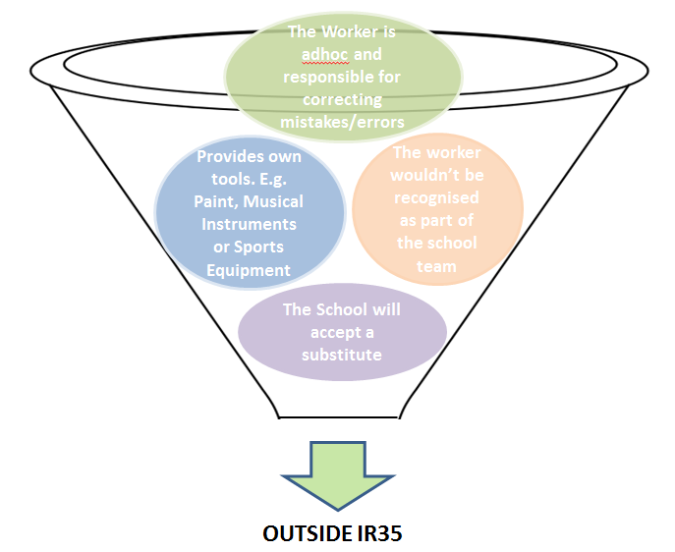**What do I do if the status is outside IR35?**

You will need to send a completed:

* Programme of Works – Direct Sourced Off-Payroll form and
* A completed HMRC – Check Employment Status for tax (CEST) - follow this link: <https://www.gov.uk/guidance/check-employment-status-for-tax>, then send to: [ir35@buckscc.gov.uk](mailto:ir35@buckscc.gov.uk) for review.

***If the information is incomplete then it will be returned for completion and it will delay the process.***

If all of the below points apply to the proposed assignment it may be outside of IR35, however, it is still necessary to complete and return the HMRC CEST and PoW to [ir35@buckscc.gov.uk](mailto:ir35@buckscc.gov.uk) for verification. 

***Role of the IR35 Assurance Group***

Complete assessments will be sent to the IR35 Assurance Group for verification. There is a 14 day turnaround from complete assessments being submitted.

If the IR35 Assurance Group is unclear about the rationale supporting your determination they will ask for further information. If on the basis of the facts submitted the Assurance Group’s determination is that the assignment is inside IR35 then you will provided with a rationale.

If you believe that the decision of inside status is inconsistent with the facts you will be asked to provide additional information to support your case.

Should you remain unhappy with the inside IR35 determination you may ask for the case to be reviewed by the Director HR&OD and Director Finance & Assets by sending it to: [ir35@buckscc.gov.uk](mailto:ir35@buckscc.gov.uk)

1. **How do I process payment?** 
   1. ***Inside IR35 Assessments:***

Complete and retain the following documents

* Completed Programme of Works (POW)
* Final CEST (Check Employment Status for Tax) PDF output
* Complete Single Central Record information
  1. ***New Vendor only***

Complete the Payment Details on Programme of Work form, including the contact details of the Umbrella Agency or Payroll Bureau, and send it to the P2P team. This will allow payment to be made via the Umbrella Agency or Payroll Bureau to the off payroll worker.

* 1. ***Verified Outside IR35 Assessments:***

Using the normal vendor set-up process and attach the following documents:

Complete and retain the following documents.

* Completed Programme of Works (POW)- Direct Sourced Off- Payroll
* Final CEST (Check Employment Status for Tax) PDF output