

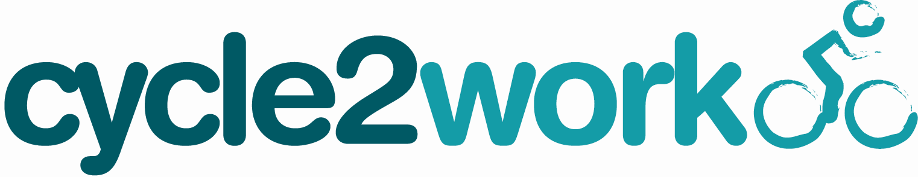
London Borough of Harrow Council
Tax Free Bike Schemes

WINDOW OPENS ALL YEAR ROUND

How to Apply – 6 easy steps

- Choose your scheme type: ‘cycleplus’ for independent stores, or ‘cycle2work’ for Halfords.

- Decide what value you want to spend on your bike and safety equipment. You can choose to take between £100 and £1,000 inclusive of VAT in increments of £5. The deductions are spread across 12 months.

  - Visit one of your local Halfords or independent stores participating in the scheme. For a full list go to: www.salaryplus.co.uk/harrowcouncil

  - Click on the scheme required and then click on ‘bike shop locator’ to help find your nearest store.

- Select the store you wish to call/visit to purchase your bike from and obtain an estimate including safety equipment if required. Then decide on the Letter of Collection (LoC/voucher) amount you wish to apply for through the scheme.

- Once you are ready to register re-visit: www.salaryplus.co.uk/harrowcouncil and select the cycleplus or cycle2work icon – and click on the ‘apply’ button or alternatively -
To register over the phone call cycleplus on 01908 303 538 or call cycle2work on 01908 303 498 or text your name and the word ‘cycles’ to 81025 and you will receive a call you back

- Please note: you will need to have a copy of your payslip to hand as you will be asked for details contained within this. Please fill in all the details as instructed, choosing the value of the Letter of Collection you require.

- Once your registration is complete you will need to print off your hire agreement.
- All documentation should be signed on company premises
- Pre-contract - PLEASE RETAIN PRE CONTRACT FOR YOUR RECORDS
- Hire Agreement - Copy 1 - You sign and retain this copy for your records.
- Hire Agreement - Copy 2 - Please sign, scan and email for HR Approval to: -

Email: StaffBenefits@harrow.gov.uk
Alternatively please post to:
HR Admin Team
3rd Floor, South Wing
Harrow Council
Civic Centre Station Road
Harrow
HA1 2XY
PLEASE Return your completed paperwork ASAP.
Once your application has been approved, your Letter of Collection (LOC) will be emailed to you where email option selected or if preferred posted to your nominated address. Please allow up to 14 working days. You then take the LOC back to your chosen store with photographic ID and exchange it for the bike and safety equipment of your choice.

The Hire Agreement is legally binding and cannot be cancelled

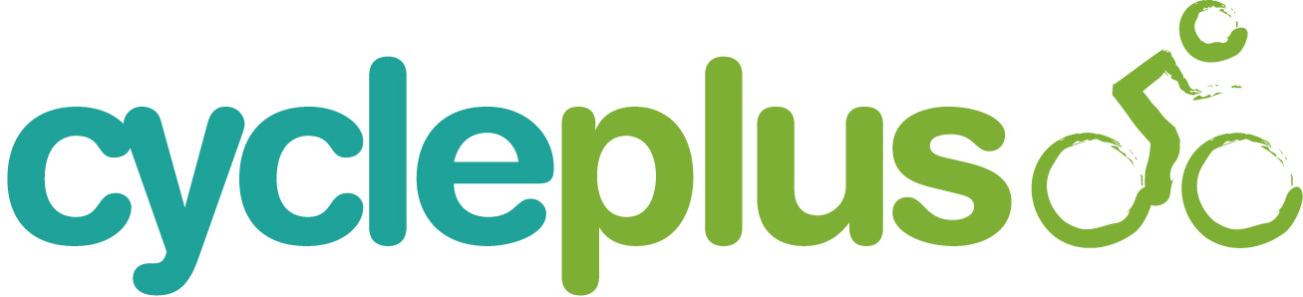

IMPORTANT INFORMATION – PLEASE READ
How does the scheme work?

- The scheme allows you to make savings FREE OF Tax and NI and will run for 12 months.

- The first deduction from salary will be made on the first available pay date after your application has been approved by HR.

- The scheme provides you with the opportunity to hire a cycle from ‘London Borough of Harrow’, FREE OF TAX AND NI. You can choose a cycle and cycle equipment to the value of between £100 and £1000 inclusive of VAT. Letters of collection are available in increments of £5 and no change will be given.

- For end of hire arrangements please refer to the FAQ’s available at www.salaryplus.co.uk/harrowcouncil

- As stated above, you do not pay tax or National Insurance contributions on the value of your vouchers. For example, if you choose a cycle and safety equipment to the value of £500 and are a lower rate tax payer, you could save up to £160.00* on the total cost, and if you are a higher rate tax payer you could save up to £210.00* spread over 12 months.
You can find a full breakdown on how much money you could save - visit: www.salaryplus.co.uk/harrowcouncil
and use the ‘my savings calculator’ for examples on savings. We have provided some example figures below for reference.

Please note all examples are illustrative only. Tax rates based on 20% and 40%. NI rates based on 12% and 2% respectively. The bike must be used by you to mainly ride to and from work, although it can be used for leisure purposes providing this is not in excess of 50% of the overall usage. Scheme regulations do not allow you to top up the value of the LoC.

*exact savings are subject to your individual tax and national insurance calculations

Please note any arrangements that may be made regarding ownership of the bike at the end of the ‘Hire agreement’ will be subject to a separate agreement.

PLEASE NOTE THE HIRE AGREEMENT CANNOT BE CANCELLED AT ANYTIME .
THE HIRE AGREEMENT IS LEGALLY BINDING

